TCP: (by default)

Port Scanning With Nmap

Nmap ip-address
Syn scan on 1000 ports
By default it scan the 1000 ports.
When we are dealing with the window it block the icmp ping packet so it seems to be down and then we use the
-Pn (it does not check that the host is up or not it directly does the port scan)

Nmap -Pn -p- ip-address
For scanning all the port

For specific port
Nmap -p 90 ip-address

Filtered means that there is the chance that the port hasd the firewall or it is closed.

Nmap -Pn -F ip-address
Fast scan on the first 100 ports.

UDP: ) sU ( it is good to checkl also the UDP port scan as the specific services run on the UDP such as DNS)
Nmap -Pn -sU ip-address
Nmap -Pn -F ip-address -v

It display all the things happing in the background.

Identify the services version on the open ports:

Nmap -Pn -sV -F ip-addess
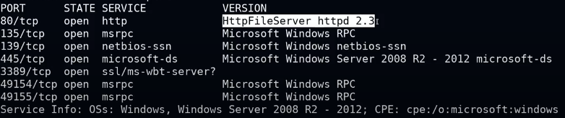

Nmap -Pn -sV -F -O ip-addess (not always acurate)
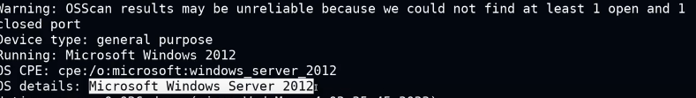

Default nmap script:
Nmap -Pn -sV -F -O -sC ip-addess / Nmap -Pn -F -A ip-addess
It give more detailed information sabout the services version in detail.

The Aggressive scan
-A = -sV -O -sC

Timing tamplate;
(the amount of the packet being sent)
T1 to T5
Higher is faster

Slow down if there is IDS IN THE network.

Nmap -Pn -F -A -T5 ip-addess

Nmap provide the output in the 3 main format.
Output your nmap scan on to the file:

Nmap -Pn -F -A -T5 ip-addess -oN test.txt

Nmap -Pn -F -A -T5 ip-addess -oX test.xml

oX (xml) == This output can be imported in the Metasploit framework.

